User Guide — Whiteboarder
──────────────────────────────────────────────────

Overview
Whiteboarder can:
- create flowcharts, sequence diagrams, ER diagrams, system architectures, and mind maps;
- generate diagrams from plain-language prompts;
- convert sketches into editable nodes and connections;
- import Mermaid, SQL, draw.io, and Excalidraw diagrams;
- edit diagrams through chat or directly on the canvas;
- arrange, save, reopen, search, and export boards.
──────────────────────────────────────────────────

Workspace
A board contains a structured diagram canvas, an optional freehand canvas, a chat panel, and a header with the board name and save state.
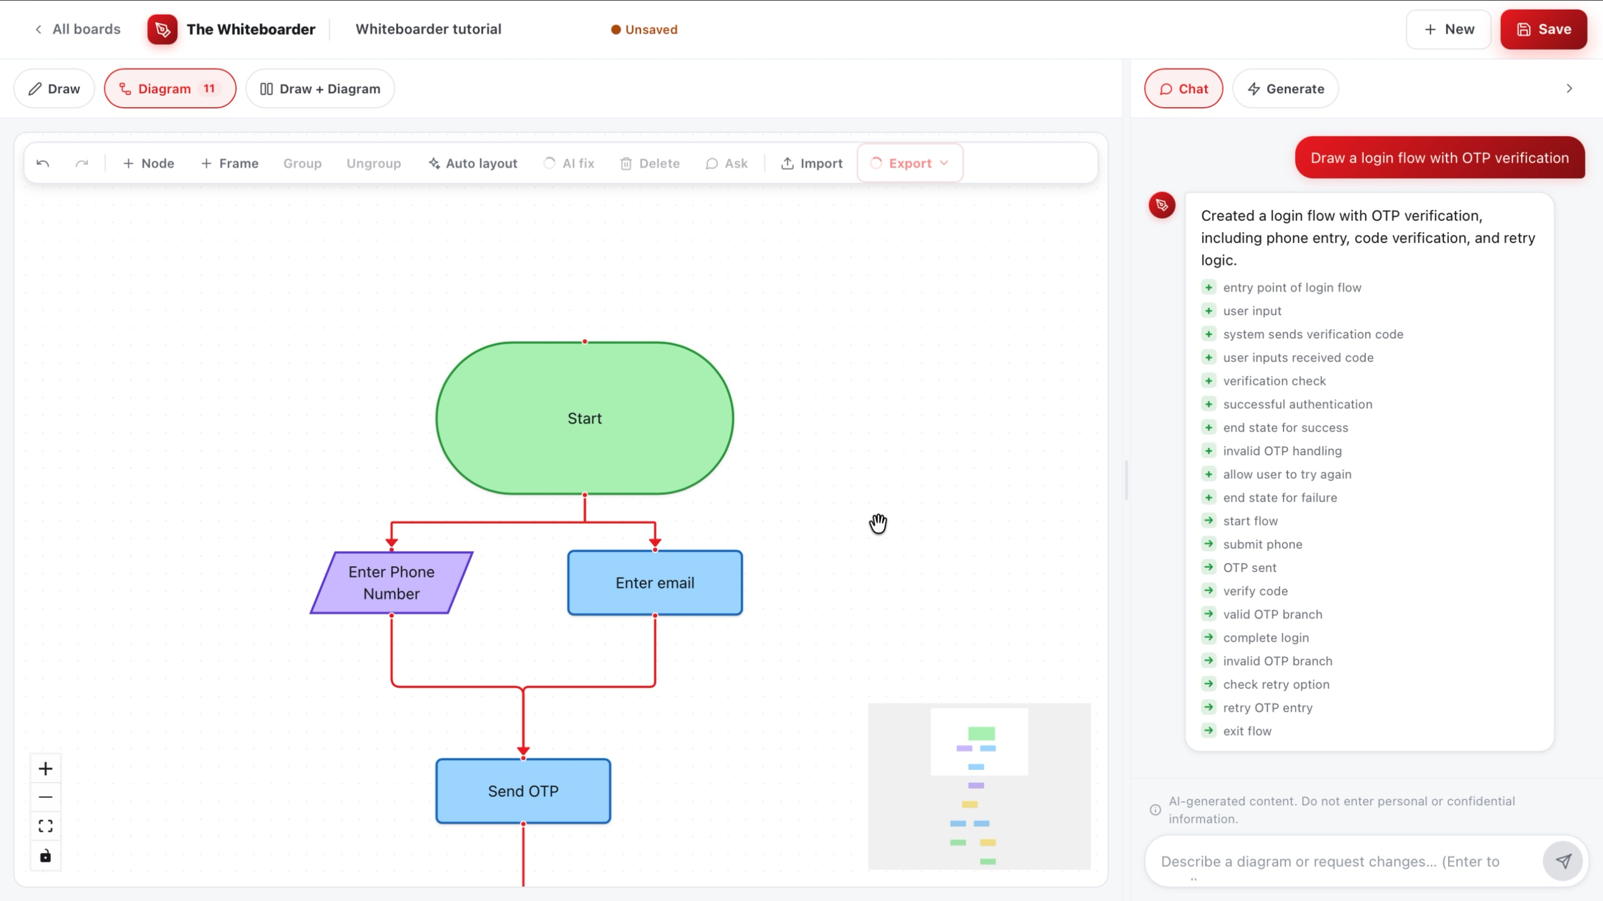
Figure 1. Whiteboarder workspace.
Control | Function
All boards | Open the board list.
New | Start another board.
Save | Save the diagram, sketch, chat, and thumbnail.
Draw / Diagram / Draw + Diagram | Switch between freehand, structured, or combined work.
Auto layout | Rearrange nodes for clearer spacing.
AI fix | Review and repair layout problems.
Ask | Ask about the current board or request an edit.
Import / Export | Bring in or download diagram content.
──────────────────────────────────────────────────

Create a board
- Open All boards.
- Select New board.
- Enter a board name.
- Select Blank board or a template.
- Select Create board.
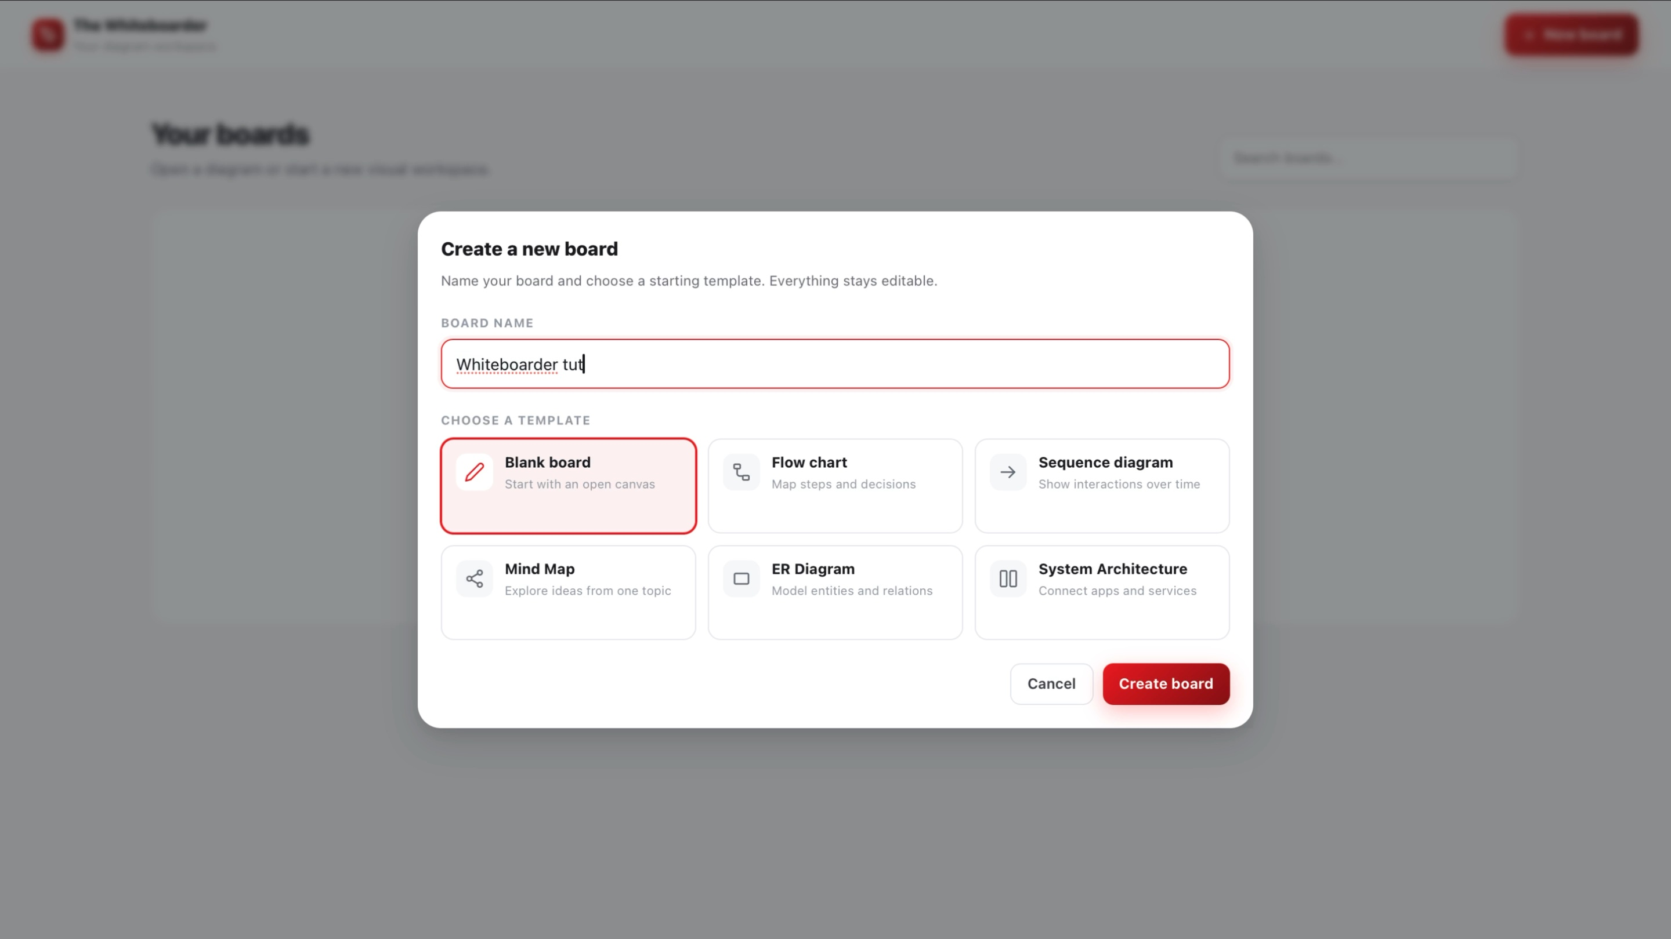
Figure 2. New board dialog.
Templates include Flow chart, Sequence diagram, Mind Map, ER Diagram, and System Architecture.
──────────────────────────────────────────────────

Generate and edit a diagram
- Select Diagram or Draw + Diagram.
- Enter a prompt describing the diagram, its important nodes, and their connections.
- Submit the prompt in the chat panel.
- Review the generated nodes and edges on the canvas.
- Ask for changes in the same conversation.
Example:
Create a flowchart for login with OTP verification, invalid-code retry, success, and failure states.
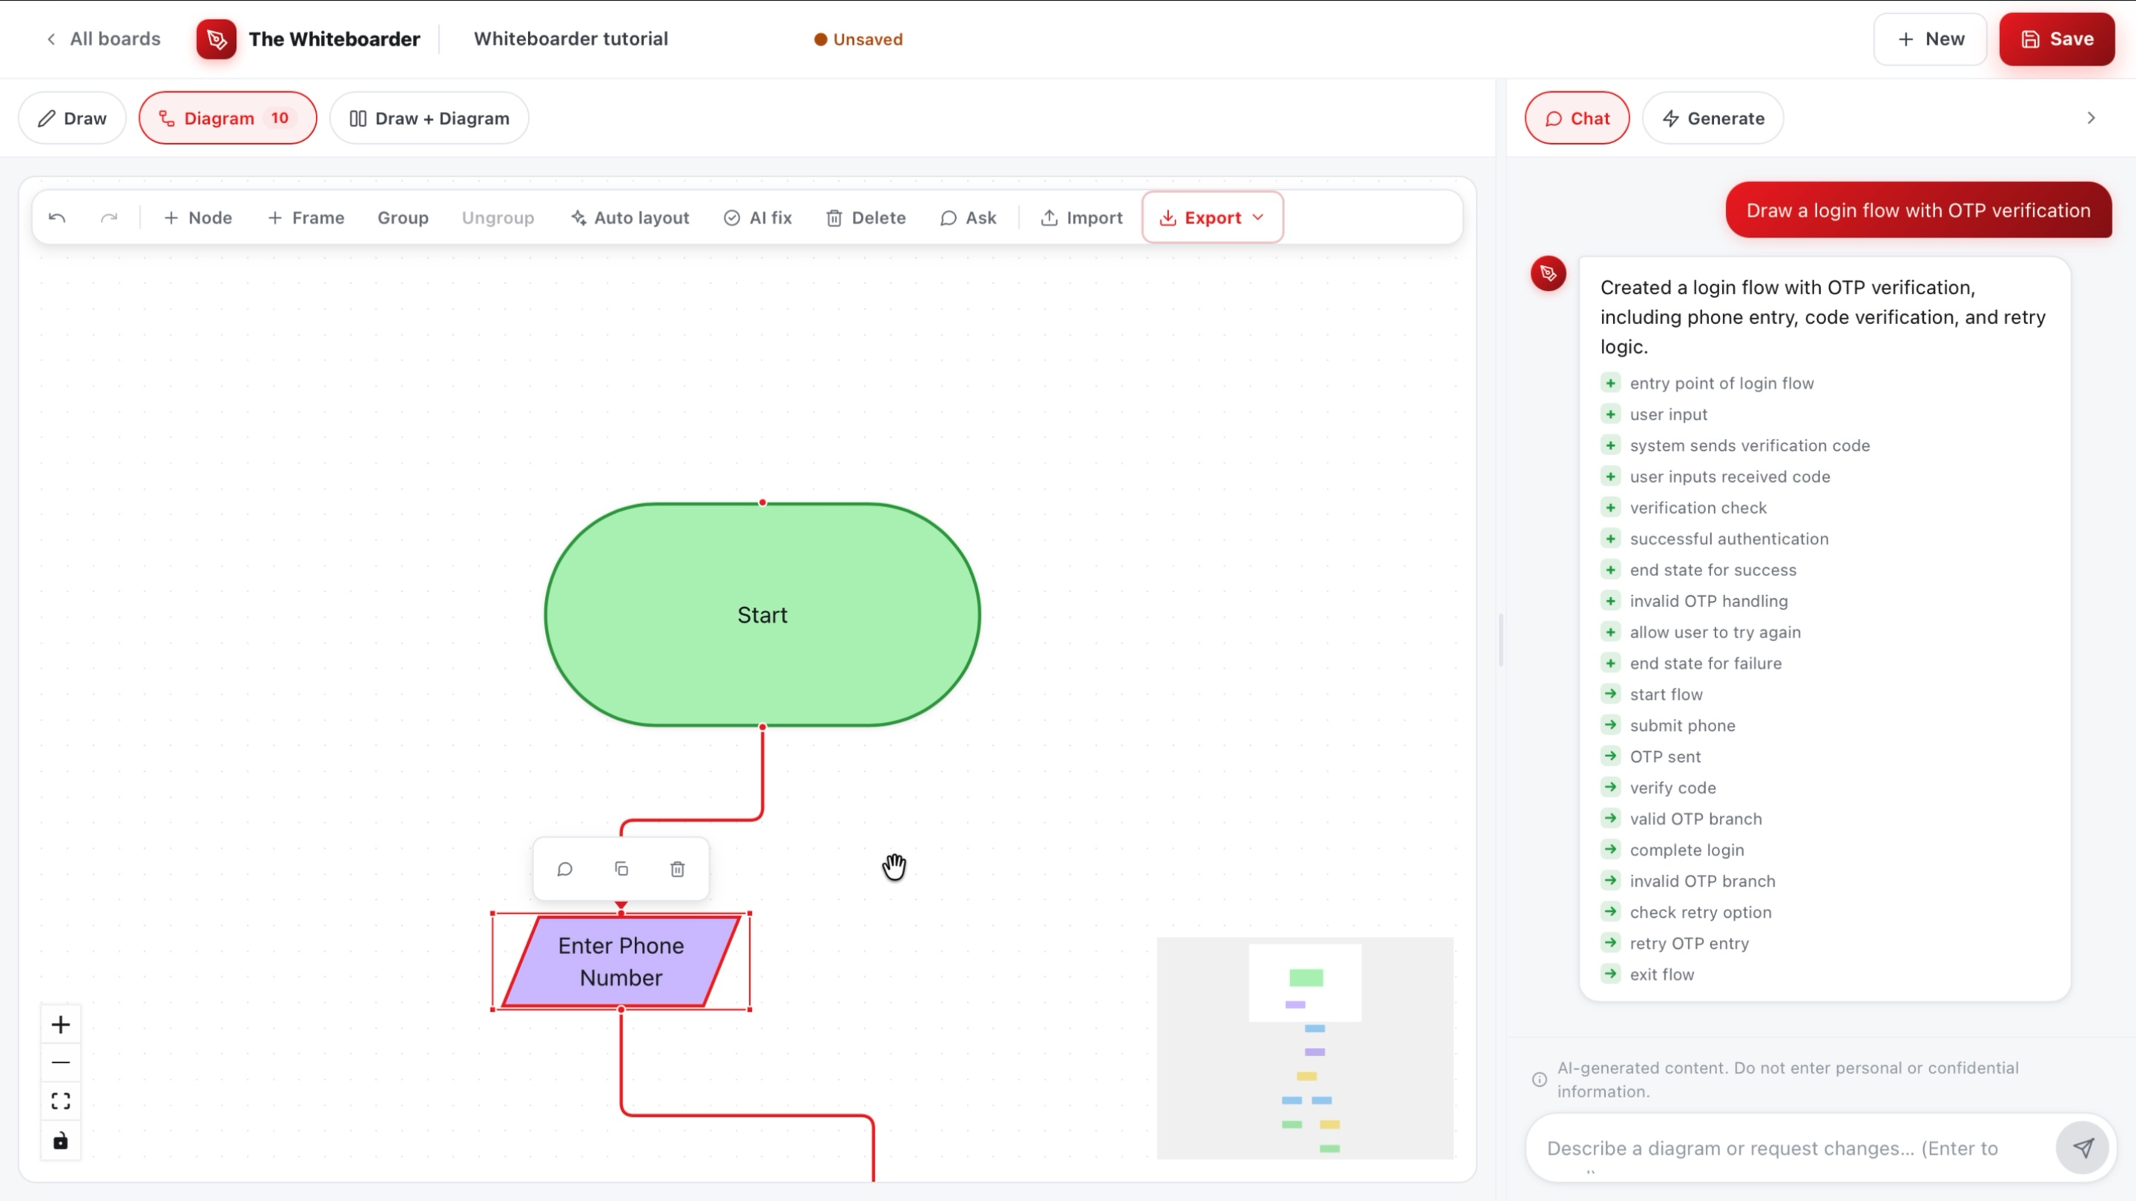
Figure 3. Diagram generation and editing.
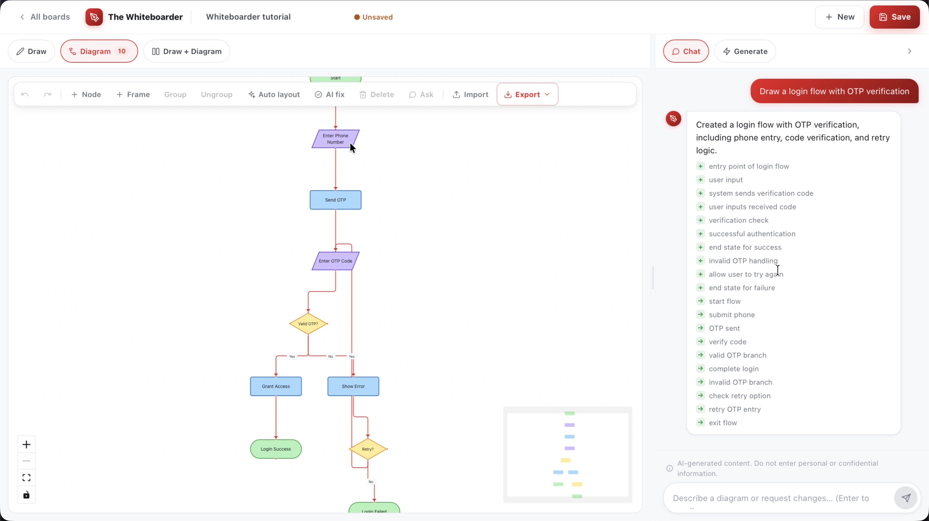
WB-07. The prompt, generated login flow, and assistant response.

AI layout and AI fix
After generating or editing a diagram:
- AI layout / Auto layout automatically rearranges nodes to improve spacing and readability.
- AI fix reviews the diagram for overlaps, dangling connections, clipped labels, or other layout problems and suggests or applies repairs.
──────────────────────────────────────────────────

Convert a sketch into a diagram
- Select Draw or Draw + Diagram.
- Draw boxes, arrows, labels, and notes.
- Ask: Generate a diagram from my sketch.
- Check the detected labels and connection directions.
- Ask for additional nodes or edits.
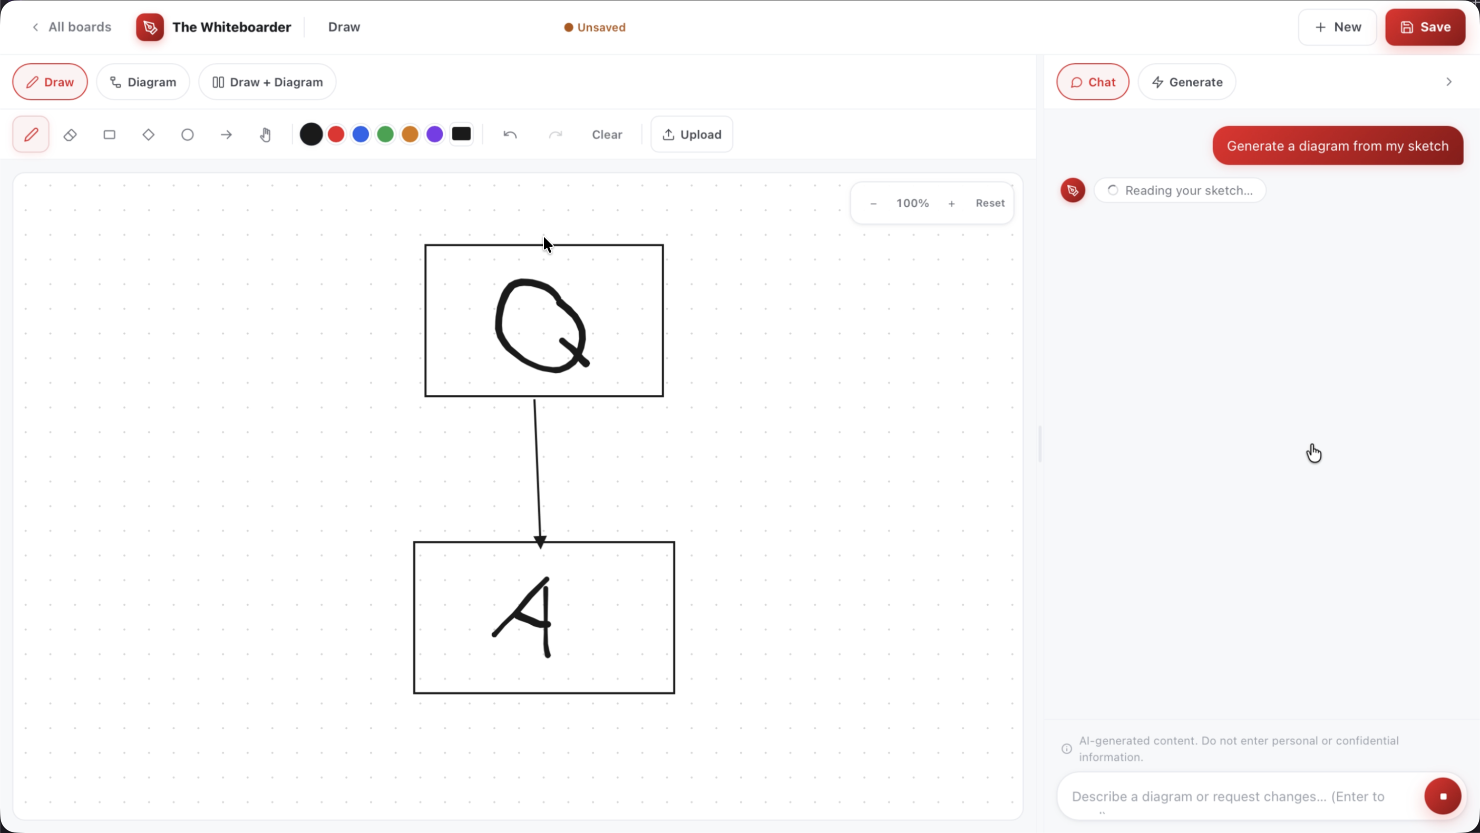
Figure 4. Sketch conversion result.
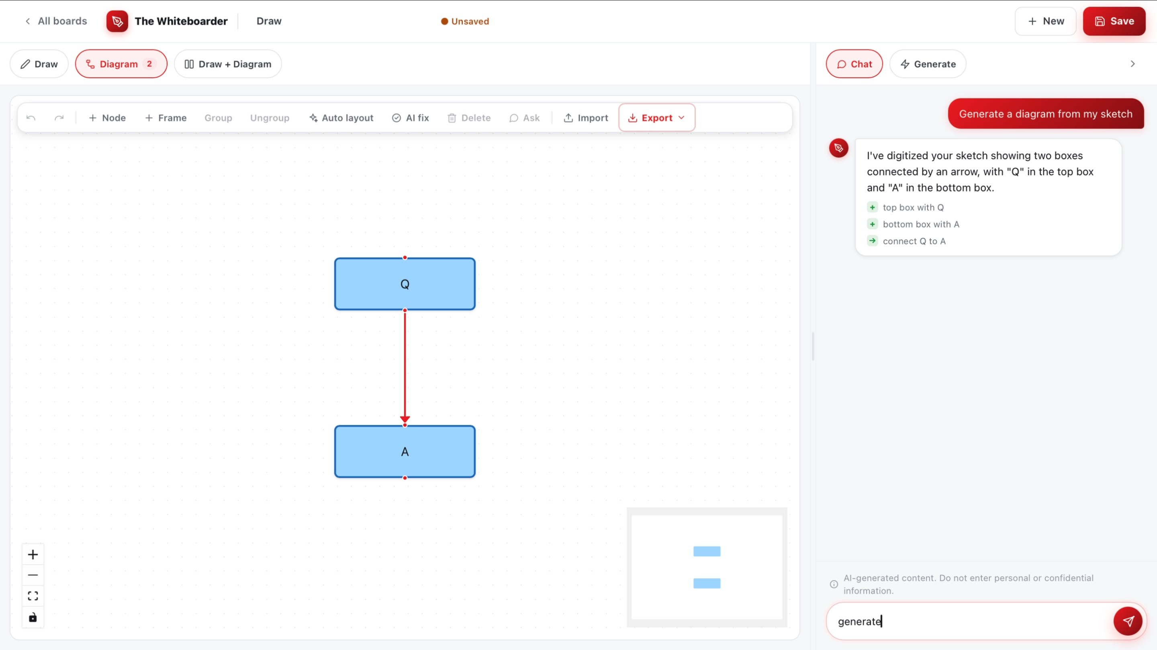
WB-08. Initial sketch with labeled boxes and an arrow.
Supported sketch uploads include PNG, JPG/JPEG, and WebP.
──────────────────────────────────────────────────

Import a diagram
Import supports:
Format | Input
Mermaid | Mermaid diagram text
SQL → ER | CREATE TABLE statements
draw.io | .drawio file or compatible XML
Excalidraw | Excalidraw diagram file or content
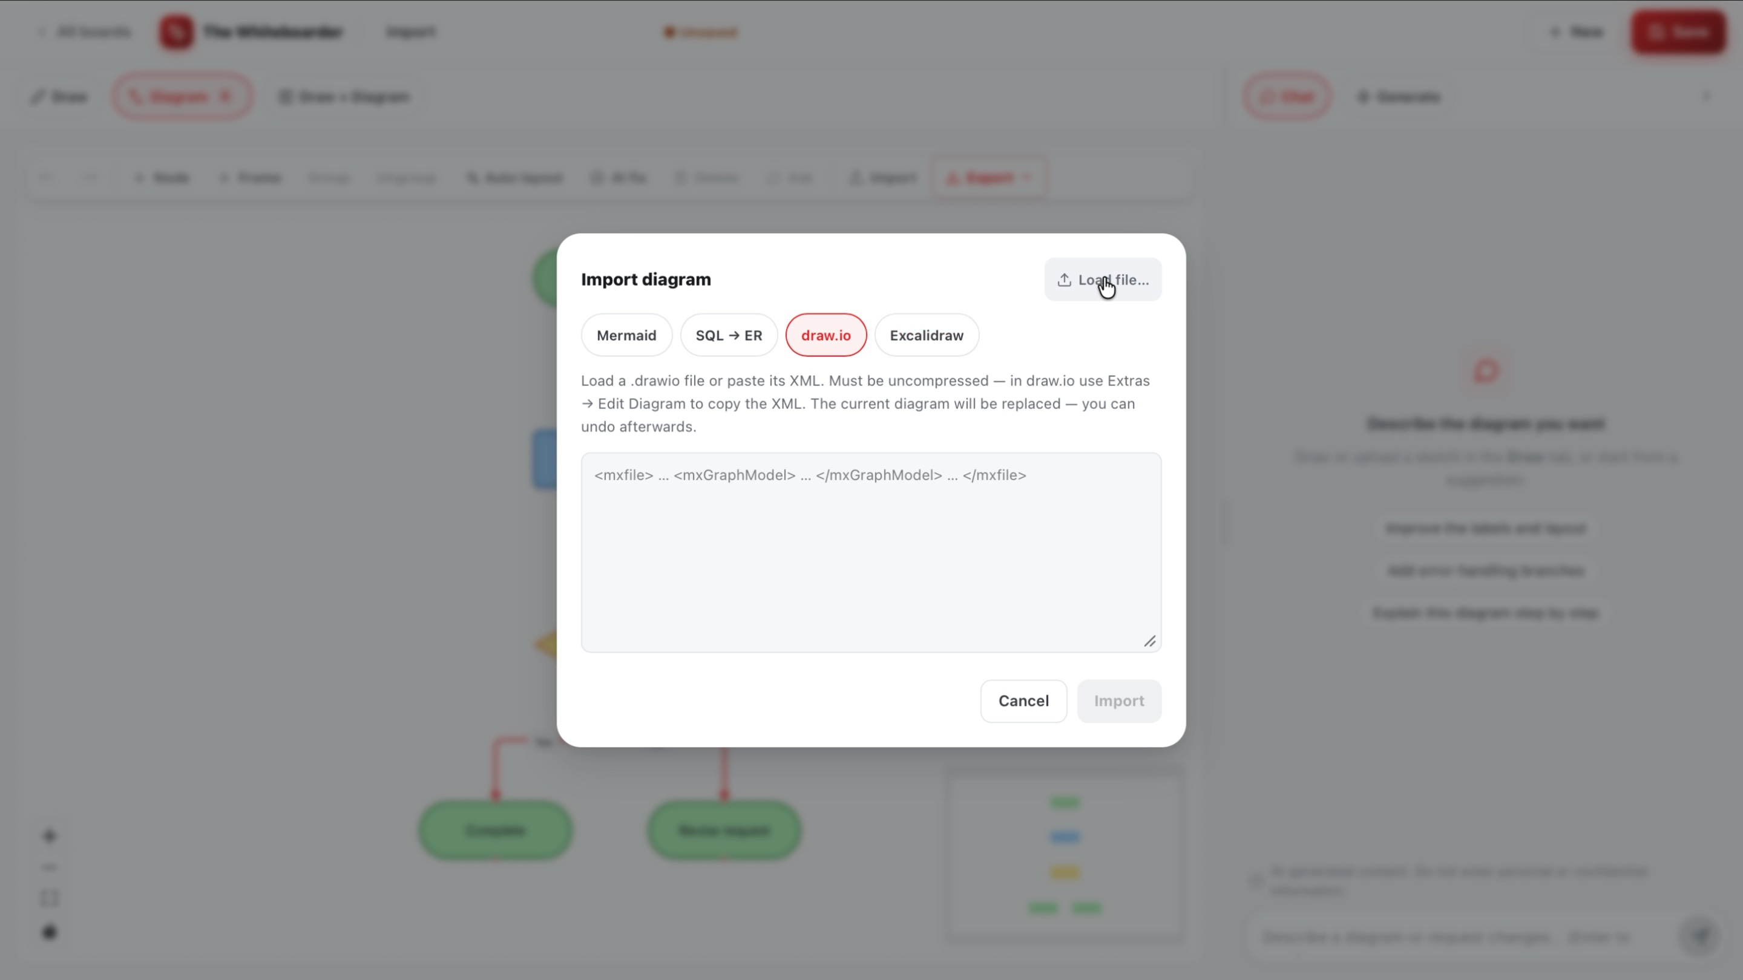
Figure 5. Import options.
──────────────────────────────────────────────────

Arrange, save, reopen, and export
- Use the canvas tools to add, move, group, or delete nodes.
- Select Save to store the diagram, freehand canvas, chat, and thumbnail.
- Open All boards to reopen a saved board or search by board name.
- Select Export to download the diagram as draw.io, XMind, or Excalidraw.
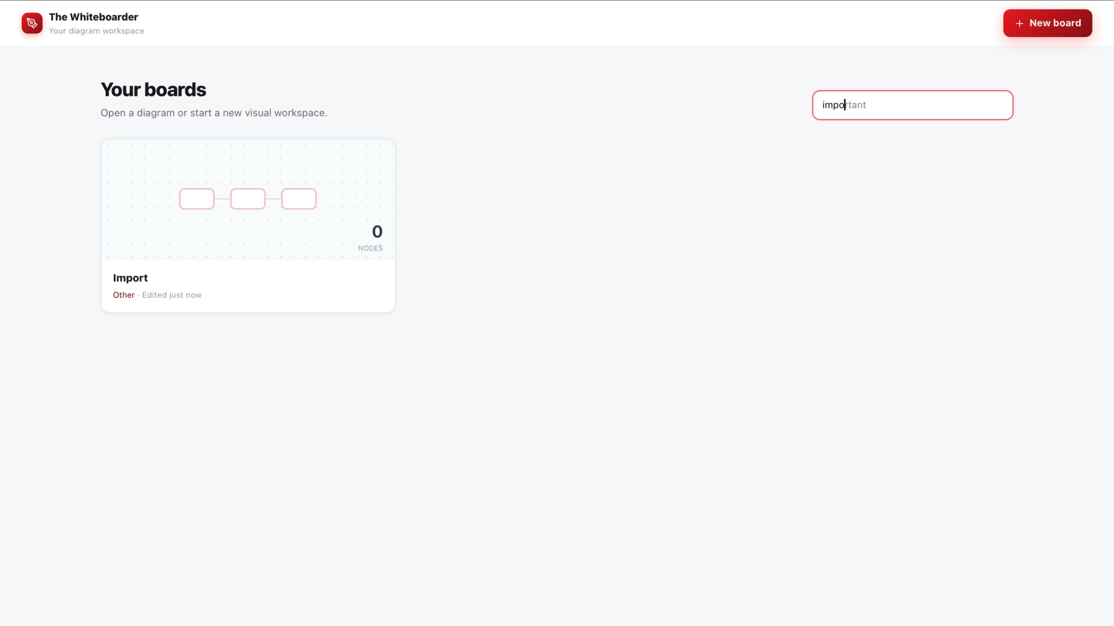
Figure 6. All boards page with search.
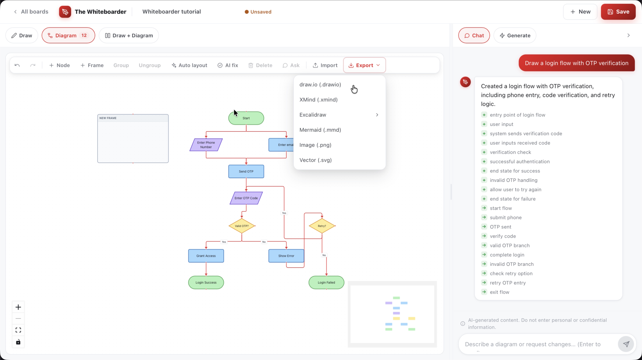
Export menu with draw.io, XMind, Excalidraw, Mermaid, Image, and Vector options.
──────────────────────────────────────────────────

Tips
- Name the diagram type, important nodes, and connections in each prompt.
- Use the same conversation for follow-up edits.
- Run Auto layout after large edits or imports, then review the result with AI fix.
- Save before importing, exporting, or leaving the board.
- Use representative labels instead of personal or confidential information.
──────────────────────────────────────────────────

Limitations
- AI-generated nodes, labels, and relationships should be checked before use.
- Auto layout and AI fix can move diagram content; they do not replace a manual review.
- Import replaces the current diagram.
- Chat changes are not persisted as a server-side checkpoint until the board is saved.
- The documented export formats are draw.io, XMind, and Excalidraw. PNG/SVG export, when available, is client-side.
──────────────────────────────────────────────────
Last updated at: 28/07/2026

